FlashSign — Software Requirements Specification
Nov 2, 2026 · @Sandaru

0. Document control
This SRS states what FlashSign must do: e-signature agreements, project and task tracking, and an AI agent hub that turns an SRS into reviewed tasks. It follows the layout of The Pitch Functional Requirement Document. Each module gives its purpose, a requirement table, business rules, the workflow, the logic or state model, and Given/When/Then acceptance criteria.
Item | Value
Product | FlashSign (Flash Technologies Ltd.)
Version | 2.0 draft, replaces docs/SRS.md
Baseline build | Front-end prototype flash-sign-proto, commit f072423 (Next.js 16, React 19, TypeScript, Tailwind 4)
Sources | Prototype code (wins on any conflict) · Agreements gap analysis.md · Features version 2.md (not used for Agreements) · original Flash Sign code
Audience | Developers, QA, product owner
How to read the requirement IDs
Prefix | Module
REQ-PLT | Platform, navigation, roles
REQ-DOC | Document library and PDF storage
REQ-AGR | Agreements: requests, fields, sending, lifecycle
REQ-SGN | Signer experience
REQ-PRJ | Projects, plan levels, boards
REQ-TSK | Tasks and the work timer
REQ-AI | AI Agent Hub, MCP and SRS analyser
NFR | Non-functional requirements
Priority is MoSCoW: M = must, S = should, C = could. Status says where the requirement stands today:
- Built works in the prototype.
- Demo works in the prototype with simulated data, such as email shown in an Outbox.
- New is not built yet and is required for production.
"Shall" marks a binding requirement. Every requirement with status Demo or New also needs the production backend described in §1.2.

1. Executive summary and domain architecture

1.1 Product vision
FlashSign is one workspace for a delivery company's two paper trails: the agreements a project starts with, and the work that delivers it. A sales or delivery lead signs the SOW or NDA in Agreements. The project manager turns the client's SRS into reviewed tasks with the AI Agent Hub. Developers (or their AI coding agents) then work those tasks with automatic time tracking.
Module | What it delivers | Section
Agreements and e-signature | Upload a PDF, sign it yourself or collect signatures in order, get a flattened signed PDF with an audit trail | §2
Projects and tasks | Projects with chosen plan levels, boards, sprints, a work timer driven by status, health and timeline reports | §3
AI Agent Hub and SRS analyser | Connect Claude Code, Codex, Gemini CLI or Antigravity through MCP; turn an SRS into proposed tasks behind a human review gate | §4

1.2 Architecture: prototype and target
The prototype runs fully in the browser. Production keeps the same screens and moves state, files, email, scheduling and the MCP server to a backend. Every requirement marked Demo or New depends on that move.
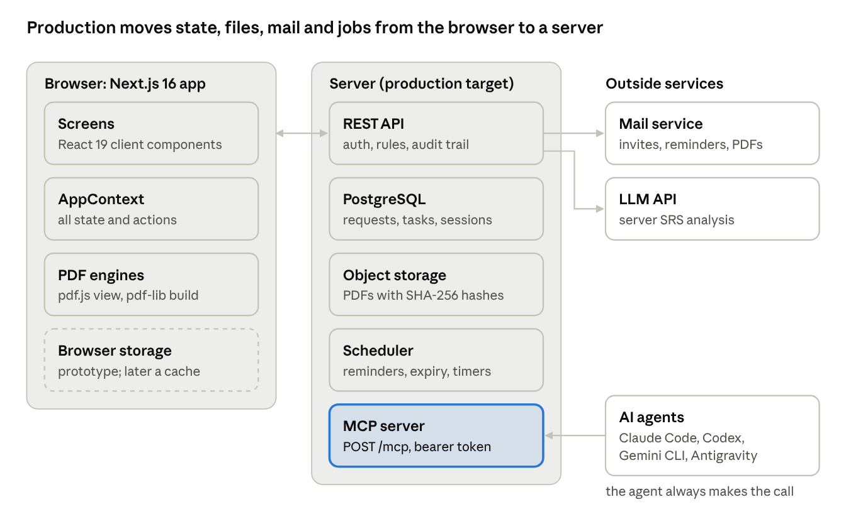
target architecture · browser, server, outside services
The browser keeps the screens and both PDF engines. Everything that must be shared, scheduled or trusted moves to the server. Agents reach FlashSign only through the MCP server, and always start the call.
Concern | Prototype (today) | Production (target)
UI | Next.js 16 App Router, React 19, TypeScript, Tailwind 4; client components | Same
App state | One React context (AppContext), saved to localStorage key flashsign-proto-state-v6 | REST/JSON API over a relational database (PostgreSQL); the client caches data
Files | PDF bytes in IndexedDB (flashsign-demo-files) | Object storage (S3-compatible), with a SHA-256 hash for each file
PDF viewing | pdf.js 6 (legacy build), worker at /pdf.worker.min.mjs | Same (client)
PDF building | pdf-lib 1.17 in the browser | pdf-lib or an equivalent on the server, plus PAdES signing
Email | Logged to emails[] and shown in the Outbox | Transactional mail service with delivery events
Scheduler | 60 s setInterval in the open tab | Server cron or job queue
Auth | Demo accounts; Demo123! for every account | Email + password with hashing, SSO later; per-signer link tokens
AI agents | MCP shown in a simulated walkthrough | MCP server (Streamable HTTP) with bearer tokens

1.3 Core concepts developers need
Legal basis for e-signatures. An electronic signature is legally valid in most jurisdictions when four things can be proven:
- Intent: the signer meant to sign. FlashSign proves this with an explicit Adopt-and-sign action.
- Consent: the signer agreed to do business electronically. FlashSign proves this with the consent checkbox.
- Attribution: the signature belongs to that person. FlashSign proves this with an email-bound link, plus IP address and user agent in production.
- Integrity: the record has not changed since signing. FlashSign proves this with hashes and a PAdES signature.
The main laws are the US ESIGN Act and UETA, the EU eIDAS regulation, and Sri Lanka's Electronic Transactions Act No. 19 of 2006. eIDAS has three levels: simple (SES), advanced (AdES) and qualified (QES). FlashSign targets SES with a strong audit trail; AdES or QES would need certificate-based signer identity. The governing jurisdiction is an open question (§6).
Hashes and tamper evidence. SHA-256 turns a file into a 64-character fingerprint, and changing one byte changes the fingerprint. FlashSign stores the hash of each original and of the final PDF. A hash chain makes each audit event include the previous event's hash, so a deleted or edited event breaks the chain. A PAdES signature with an RFC 3161 timestamp makes the PDF itself show "modified" in any PDF reader if it is altered.
Page coordinates. Field positions are stored as page percentages, so they stay right at any zoom and on any device. They are converted to PDF points only when the final file is built (§2.3).
MCP (Model Context Protocol). MCP is an open protocol that lets an AI agent use outside tools. The agent is the client: it starts every call (tools/list, tools/call). FlashSign is the server: it lists its tools and answers calls. The server cannot start a conversation or wake an agent. That is what "MCP is one-way" means: data flows both ways, but the agent always starts. FlashSign therefore uses a pull design. The web app marks work as waiting, and the agent asks for it when a person tells it to. Optional MCP features, such as sampling (the server asks the client's model to write text) and notifications, depend on the client and are not relied on (§4.1).
Browser storage. localStorage holds about 5 MB of text per site and blocks the page while it writes. It suits small state only. IndexedDB holds binary data and is limited only by the browser's disk quota, so PDFs go there (§5.1).

1.4 Personas and permissions
Persona | App roles (DemoRole) | Main goals
Admin | org_admin, ceo, platform_admin | Set up the organisation, members, signing defaults, agent policy and tokens
PM / Creator | project_manager, product_owner, engineering_lead | Create projects and plans, send agreements, analyse SRS documents, review proposed tasks
Developer | developer, qa_tester | Work tasks on the board or through an AI agent; log time
Document manager | document_manager | Manage the document library and templates
Observer | client, auditor | Read projects, reports and audit trails
External signer | No account | Open an emailed link, sign or decline, receive the signed PDF

Action | Admin | PM / Creator | Developer | External signer
Create a project; edit plan, boards and structure | Yes | Yes | No | —
Create and move tasks | Yes | Yes | Yes | —
Log or correct time for others | Yes | PM and engineering lead | No | —
Send agreements; sign it yourself | Yes | Yes | Yes | —
Sign or decline a request sent to them | Yes | Yes | Yes | Yes (own fields only)
Run SRS analysis; accept proposed tasks | Yes | Yes | No | —
Create or revoke own agent tokens | Yes | Yes | Yes | —
Organisation agent policy, revoke anyone's token | Yes | No | No | —

ID | Requirement | Pri | Status
REQ-PLT-001 | Each permission above shall be enforced on every route and API call, not only by hiding buttons. | M | New (today only Create project, plan and board editing, team time and agent organisation are checked)
REQ-PLT-002 | After login, the user's role shall come from their account. | M | Built
REQ-PLT-003 | The sidebar shall show Workspace (Dashboard, Projects, My Tasks, Planning), Agreements (Home, Inbox, Documents, Templates, Reports, Settings), Teams, AI Agent Hub and Settings. | M | Built
REQ-PLT-004 | Sidebar groups shall be filtered by the role's navGroups. | S | New
REQ-PLT-005 | Every create, update and delete shall write an activity record that is kept (today auditLogs and activities are lost on reload). | M | New

2. E-Signature & Agreements engine
Agreements lets a user upload real PDFs and then sign them alone or collect signatures from others, in order or all at once. Every request ends in one flattened PDF with a signing summary page. This module is specified from the prototype code (src/app/(workspace)/signatures/**, src/components/pdf/**, src/lib/pdf/**, src/context/app-context.tsx), not from Features version 2.

2.0 Screens and routes
Screen | Route | Purpose
Agreements home | /agreements | Start actions: Sign it yourself, Get signatures, Use a template
Inbox | /signatures/all | Every visible request, with status, "waiting on me" and "sent by me" filters, paging and bulk actions
Drafts | /signatures/drafts | Unsent requests, with Continue and Delete
Outbox | /signatures/outbox | Simulated emails (demo only; real email replaces it in production)
Trash | /signatures/trash | Deleted requests, with Restore and Delete forever
Upload wizard | /signatures/upload?mode=self|send[&draft=<id>][&documentId=<id>] | Prepare a request
Request detail | /signatures/[requestId] | Status, signers, emails, audit trail, downloads, Cancel
Signing page | /signatures/sign/[requestId]?as=<signerId> | Where a signer fills in fields and signs
Documents | /documents, /documents/new, /documents/[id] | Library of uploaded PDFs and text documents
Signing settings | /signatures/settings | Organisation defaults, saved signature, company seals

2.1 Document management and PDF storage
Purpose: take in a real PDF, keep it across reloads, show its pages and reuse it in any number of signature requests.
ID | Requirement | Pri | Status
REQ-DOC-001 | The system shall accept PDF files only, chosen by file picker or drag and drop, from the Upload wizard and from Documents › New › Upload PDF. | M | Built
REQ-DOC-002 | The system shall reject a file larger than 5 MB (MAX_PDF_BYTES = 5 × 1024 × 1024) with "This file is larger than 5 MB." | M | Built
REQ-DOC-003 | The system shall reject a file whose MIME type is not application/pdf and whose name does not end in .pdf, with "Only PDF files can be uploaded." | M | Built
REQ-DOC-004 | The system shall read the first bytes and reject a file without the %PDF- header, with "This file is not a valid PDF." | M | Built
REQ-DOC-005 | The system shall open the PDF with pdf.js and reject it if it cannot be parsed or is password-protected ("this PDF could not be opened"). The page count is read at upload. | M | Built
REQ-DOC-006 | When several files are picked, each shall be checked on its own; good files are added and each failure is listed by file name. | M | Built
REQ-DOC-007 | The PDF bytes shall be stored under a generated fileId (IndexedDB database flashsign-demo-files, store files). Only the metadata (PdfAttachment) is kept in app state. | M | Demo
REQ-DOC-008 | Every PDF uploaded in the wizard shall also become a Documents item (type: 'pdf', status: 'draft', read-only), so it can be reused. Built-in samples are not added. | M | Built
REQ-DOC-009 | The Documents viewer shall render every page with zoom and offer Export (original PDF), Sign it yourself and Send for signature. It also lists the requests that use the document. | M | Built
REQ-DOC-010 | A document's status shall follow its requests: pending when a request using it is sent, and signed when that request completes. | M | Built
REQ-DOC-011 | The system shall offer three built-in sample PDFs (nda 2 pages, offer 1 page, services 2 pages), generated in the browser with pdf-lib. If a sample's stored bytes are missing, they are rebuilt from sampleId. | S | Demo
REQ-DOC-012 | In production the file shall be stored in object storage and its SHA-256 hash recorded at upload (see §2.8). | M | New
Business rules
- A request may hold several PDFs (pdfs[], in order). pdf is always pdfs[0].
- Deleting a document from a draft also removes every field placed on it.
- Text documents written in the Documents editor still use the older text-based signing flow. Only PDFs use the engine in this section.
Upload check (logic)
readPdfUpload(file):
if file.type != 'application/pdf' and !file.name.endsWith('.pdf') -> error 'Only PDF files can be uploaded.'
if file.size > 5 MB -> error 'This file is larger than 5 MB.'
if !firstBytes(file).includes('%PDF-') -> error 'This file is not a valid PDF.'
bytes = file.bytes; pageCount = pdfjs.open(bytes).numPages // throws -> 'could not be opened'
fileId = newFileId(); savePdfFile(fileId, bytes)
return { fileId, name, sizeBytes, pageCount }

2.2 Data model
Entity | Key fields | Notes
PdfAttachment | fileId, name, sizeBytes, pageCount, sampleId?, documentId? | Points at the stored bytes
SignatureRequest | id, title, senderId, signers[], ccRecipients[], signingOrder, status, fields[], pdfs[], selfSign, message, expiresAt, reminderFrequency, lastReminderAt, emails[], events[], draft?, deletedAt? | One envelope
SignatureSigner | id, name, email, order, status, viewedAt, signedAt, declinedAt, declineReason, signatureValue, color | Status: waiting · pending · viewed · signed · declined
CopyRecipient | id, name, email, role: 'copy' | 'view' | Does not sign; gets the finished PDF
SignatureField | id, type, signerId, fileId, pageNumber, positionX, positionY, width, height, required, options?, value? | Position and size are page percentages
AuditEvent | id, requestId, eventName, actorName, actorEmail, description, category, timestamp, ipAddress? | Append-only trail
DemoEmail | kind, toName, toEmail, subject, body, signerId?, withSignedPdf?, sentAt | Replaced by a real mail queue in production

2.3 Field engine and coordinates
Coordinate system (read this before building). A PDF page is measured in points (1/72 inch), with the origin at the bottom-left. Screens are measured in pixels, with the origin at the top-left, and every zoom level gives a different pixel size. FlashSign therefore stores each field as percentages of its page: positionX/positionY is the field's top-left corner and width/height its size, each from 0 to 100. The same numbers then fit any zoom, device or the final PDF. To write a field into the PDF (page size W × H points):
x_{pt} = \frac{X}{100} W, \quad w_{pt} = \frac{w}{100} W, \quad h_{pt} = \frac{h}{100} H, \quad y_{pt} = H - \frac{Y}{100} H - h_{pt}
y_pt is the field's bottom edge in PDF space, which is where pdf-lib's drawImage and drawText start.
Type | Label | Default size (w × h %) | Filled how | Required by default
signature | Signature | 26 × 5.5 | Adopted signature image | Yes
initials | Initials | 10 × 5 | Adopted initials image | Yes
date | Date Signed | 16 × 3 | Filled automatically with the signing date | Yes
name | Full Name | 24 × 3 | Pre-filled from the signer, editable | Yes
email | Email | 28 × 3 | Pre-filled from the signer, editable | Yes
company | Company | 24 × 3 | Pre-filled when known | Yes
title | Title | 22 × 3 | Pre-filled when known | Yes
text | Text | 24 × 3 | Free text | Yes
number | Number | 12 × 3 | Numbers only | Yes
checkbox | Checkbox | 3.2 × 2.5 | Click toggles 'true' | No
dropdown | Dropdown | 20 × 3 | One of options | Yes
radio | Radio | 26 × 3 | One of options | Yes
approve | Approve | 12 × 3.2 | Click sets 'Approved' | Yes
decline | Decline | 12 × 3.2 | Click sets 'Declined' | Yes

ID | Requirement | Pri | Status
REQ-AGR-001 | The field placer shall offer the 14 types above in groups. A field is placed by dragging it from the palette onto a page, or by choosing a type and clicking the page. | M | Built
REQ-AGR-002 | A new field shall be centred on the drop point and clamped inside the page: X ∈ [0, 100 − w], Y ∈ [0, 100 − h]. | M | Built
REQ-AGR-003 | A placed field shall be movable and resizable, with a minimum size of 2 % × 1.5 % and no part outside the page. | M | Built
REQ-AGR-004 | Each field shall belong to exactly one signer (signerId) and be drawn in that signer's colour. In send mode an assignee picker sets the signer. | M | Built
REQ-AGR-005 | Each field shall record its document (fileId) and page (pageNumber, starting at 1). | M | Built
REQ-AGR-006 | Dropdown and radio fields shall start with default options. Sending is blocked while any of them has none. | M | Built
REQ-AGR-007 | Each field's Required flag shall be editable. Checkboxes default to optional. | M | Built
REQ-AGR-008 | The placer shall support Undo (Ctrl+Z) and Redo (Ctrl+Shift+Z), keeping up to 50 steps. One drag or resize is one step. | S | Built
REQ-AGR-009 | On a sample PDF, "Add suggested fields" shall place Signature, Full Name and Date on the signature lines of the last page for the first two signers. | C | Demo
REQ-AGR-010 | The system shall handle page rotation (/Rotate) and a CropBox that differs from the MediaBox when converting coordinates. | S | New
Acceptance criteria
- Given a 612 × 792 pt page, when a Signature field is stored at X = 10, Y = 80, w = 26, h = 5.5, then the signed PDF draws it at x = 61.2 pt, y = 114.84 pt, inside a 159.12 × 43.56 pt box.
- Given a field dragged past the right edge, when it is dropped, then X + w = 100 and no part of it is cut off.
- Given three placements followed by Undo twice, when Redo is pressed once, then exactly two fields exist.

2.4 Workflow: Sign it yourself
Purpose: the user is the only signer. They place their own fields, adopt a signature and download the signed PDF at once. Nothing is sent to anyone.
Entry points: Agreements › Sign it yourself, and Documents › [PDF] › Sign it yourself (opens with that document already added).
- The user opens /signatures/upload?mode=self. The wizard shows two steps: Document → Place fields.
- Document: the user uploads one or more PDFs, picks a sample, or adds documents from the library. The title defaults to the first file name without .pdf. They can reorder or remove documents.
- Place fields: the user places fields. All of them belong to the user, who is the only signer.
- Sign now: the system creates the request with selfSign = true, signingOrder = 'sequential', reminderFrequency = 'never' and no message. It sends no email and opens /signatures/sign/<id>.
- The signing page opens in the user's own name. Name, email, company and title are pre-filled, and dates are set to today.
- The user clicks a Signature or Initials field. The Adopt signature dialog opens; see §2.6.
- The user ticks the e-record consent box and clicks Finish. The request becomes completed, a "Completed" email with the signed PDF is logged to the sender, and the signed PDF can be downloaded.
ID | Requirement | Pri | Status
REQ-AGR-020 | Self-sign mode shall show only the Document and Place fields steps. | M | Built
REQ-AGR-021 | Self-sign shall block Next until at least one document, a title and at least one field exist. | M | Built
REQ-AGR-022 | Self-sign shall send no invitation and no reminders. Only the completion notice goes to the sender. | M | Built
REQ-AGR-023 | Finishing self-sign shall offer the signed PDF for download at once, named <title> - signed.pdf. | M | Built
REQ-AGR-024 | Audit events: "Document Prepared for Signing" at creation, then "Document Signed" and "Workflow Completed". | M | Built
- Given a self-sign request with 3 fields, when the user fills every required field, ticks consent and clicks Finish, then the status is completed, completedAt is set and the download holds the original pages plus a summary page.
- Given the Finish button, when a required field is empty or consent is not ticked, then the button is disabled and shows "N required fields left".

2.5 Workflow: Get signatures from others
Purpose: send one or more PDFs to other people, each with a role, and collect signatures in a chosen order.
- Document: this step works as in §2.4. Opening the wizard from Documents › Send for signature adds that document first.
- Recipients: add people by name and email. Each person gets a role:
  - Needs to sign: becomes a SignatureSigner and gets fields.
  - Receives a copy: becomes a CopyRecipient with role copy. They get a notice now and the signed PDF at the end.
  - Needs to view: becomes a CopyRecipient with role view, treated the same as a copy.
- Choose the signing order: In order (sequential) or At the same time (parallel). Move recipients up or down to set the order. "Add me" adds the sender as a signer.
- Set the message, the expiry (30, 60, 90 or 120 days, or custom 1–999) and the reminders (daily, every 2 days, every 3 days, weekly, never). These default from Signing settings.
- Place fields: pick a signer and place that signer's fields. Preview as recipient shows one signer's view at Desktop (900 px), Tablet (720 px) or Mobile (375 px) width.
- Review & send: a summary of documents, recipients, order, expiry and field counts per signer. Send runs the full check again and creates the request.
- On send, every signer who can sign now gets an invitation with a personal link (?as=<signerId>), and every copy or view recipient gets a "shared with you" notice. The user lands on the request detail page.
Validation (shown as a list of issues; Next and Send stay disabled while any remain)
Rule | Message
No document | Upload a PDF or choose a sample document.
Blank title | Give the request a title.
No signer | Add at least one person who needs to sign.
Blank name | Recipient N needs a name.
Bad email (regex) | Recipient N needs a valid email address.
Duplicate email (case-insensitive) | Each recipient needs a different email address.
Expiry outside 1–999 | Expiry must be between 1 and 999 days.
Signer with no field | Place at least one field for <name>.
Dropdown or radio without options | A dropdown field needs at least one option.
Drafts
- From the moment one document is added, the wizard saves a draft 0.7 s after the last change. It saves the documents, title, recipients, fields, order, message, expiry, reminders, mode and current step.
- Save & close saves at once and goes to Drafts. Continue reopens the wizard at the saved step.
- Sending a draft keeps its id, so its history carries on.
ID | Requirement | Pri | Status
REQ-AGR-030 | Send mode shall have four steps: Document, Recipients, Place fields, Review & send. | M | Built
REQ-AGR-031 | Recipients shall have one of three roles: Needs to sign, Receives a copy, Needs to view. | M | Built
REQ-AGR-032 | In order: only the signer with order = 1 starts as pending; the others start as waiting. At the same time: all signers start as pending. | M | Built
REQ-AGR-033 | expiresAt = send date + expiry days (as a date). The request expires at 23:59:59 local time on that day. | M | Built
REQ-AGR-034 | Removing a recipient shall remove that recipient's fields. | M | Built
REQ-AGR-035 | Drafts shall auto-save 700 ms after the last change and appear in Drafts with Continue and Delete. | M | Built
REQ-AGR-036 | Preview as recipient shall show only the chosen signer's fields, at three device widths. | S | Built
REQ-AGR-037 | Sending shall mark linked Documents as pending. | M | Built
REQ-AGR-038 | In production, invitations shall be sent by real email with a single-use, expiring, signed link token instead of ?as=. | M | New
- Given two signers in order, when the request is sent, then only signer 1 gets an invitation and signer 2 is waiting.
- Given two recipients with emails A@x.com and a@x.com, when the user clicks Next, then "Each recipient needs a different email address" is shown.
- Given a draft saved at Place fields, when the user clicks Continue in Drafts, then the wizard opens at Place fields with all fields restored.

2.6 Signer experience
Purpose: a signer opens their link, fills in only their own fields, adopts a signature and finishes, or declines with a reason.
On open: if the signer's status is pending, it becomes viewed, viewedAt is set, and a "Document Opened" event is added. The request moves from sent to viewed.
Blocked states: these are checked in this order before any field is shown.
Condition | Screen shown
Request completed | Signed and completed (download available)
Signer already signed | You have signed (shows who it is still waiting for)
Status cancelled | This request was cancelled
Status declined or signer declined | This request was declined
Past expiresAt 23:59:59 or status expired | This request has expired
Signer waiting (in order) | It's not your turn yet (names the earlier signers)
Signing steps
- The page lists the signer's fields, with a counter ("N required fields left"), and required empty fields pulse. Clicking a field in the list jumps to it.
- Clicking a Signature or Initials field opens Adopt signature. The signer chooses one way to sign, from the methods allowed in Signing settings (allowedSignatureMethods):
  - Type: the name in one of 4 styles (formal, script, bold, elegant).
  - Draw: on a pad.
  - Upload: an image. The dialog starts from the user's saved signature (Settings › My Signature) when the signer is the logged-in user. The adopted signature is turned into a PNG (signatureToPng, 600 × 180 for a signature, 288 × 180 for initials) and fills all of that signer's signature and initials fields.
- Text fields are typed in. A checkbox toggles. Approve or Decline sets its word. A dropdown or radio picks one option. Date Signed fills itself.
- The signer ticks "I agree to use electronic records and signatures for this document."
- Finish is enabled only when nothing required is missing and consent is ticked. See §2.7 for what happens next.
- Decline asks for a reason, which is required. The signer becomes declined and the request declined. The sender is told, and no one else can sign.
ID | Requirement | Pri | Status
REQ-SGN-001 | A signer shall see and fill only their own fields. Other signers' filled values show read-only. | M | Built
REQ-SGN-002 | A signer may sign only while the request is sent, viewed or partially_signed, the signer is pending or viewed, and the request has not expired. | M | Built
REQ-SGN-003 | Signature capture shall support Type, Draw and Upload, limited to the methods the organisation allows. | M | Built
REQ-SGN-004 | Finish requires every required field to have a value and e-record consent to be ticked. | M | Built
REQ-SGN-005 | Decline requires a reason and is allowed only on the signer's turn. | M | Built
REQ-SGN-006 | Name, email, company, title and date fields shall be pre-filled when known. | S | Built
REQ-SGN-007 | Permitted roles may apply an active company seal. Each use increments its usageCount. | C | Built (text flow)
REQ-SGN-008 | In production, the signing page shall record the signer's IP address and user agent, and the time of consent, in the audit trail. | M | New
- Given signer 2 of an in-order request while signer 1 has not signed, when signer 2 opens the link, then "It's not your turn yet" names signer 1 and no fields are shown.
- Given a request whose expiresAt is yesterday, when any signer opens it, then "This request has expired" is shown, even if the scheduler has not run yet.

2.7 Envelope lifecycle and state machine
A request (the "envelope") has one status, and each signer has their own status. The request status is worked out from signer actions, the scheduler and the sender. completed, declined, expired and cancelled are final: nothing can be signed after them. Trash is separate from status: deletedAt only hides a request.
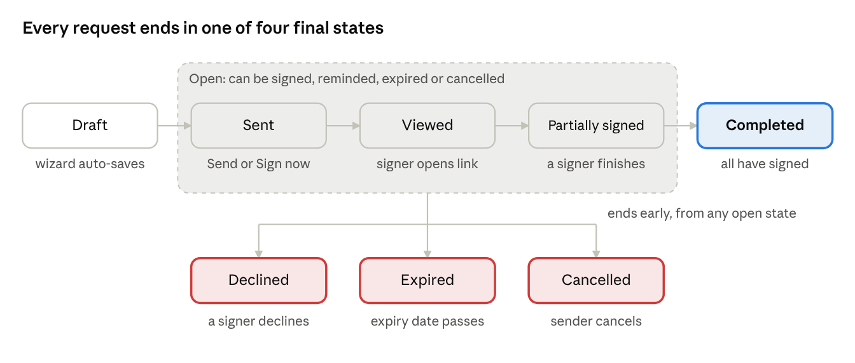
signature request lifecycle · 4 open states, 4 final states
A request with one signer goes from Viewed straight to Completed, skipping Partially signed. Only the three red exits end a request before everyone has signed.
How the brief's terms map to code
Brief term | Request status | Signer status
Draft | draft | waiting (placeholder)
In progress | sent, viewed, partially_signed | —
In turn | — | pending, then viewed
Not yet in turn | — | waiting
Completed / Declined / Expired / Cancelled | completed / declined / expired / cancelled | signed / declined
Request transitions
From | Event (function) | To | Side effects
— | First document added in wizard (saveSignatureDraft) | draft | Event "Draft Created"
draft | Send or Sign now (createPdfRequest) | sent | Invites to pending signers; copy notices; linked documents become pending
sent | A pending signer opens the link (markPdfSignerViewed) | viewed | Signer becomes viewed; event "Document Opened"
sent · viewed · partially_signed | A signer finishes and others remain (completePdfSigning) | partially_signed | In order: the next waiting signer becomes pending and is invited
sent · viewed · partially_signed | The last signer finishes | completed | completedAt; signed PDF emailed to signers, copies and sender (once per email); linked documents become signed
sent · viewed · partially_signed | A signer declines on their turn (declineSignatureRequest) | declined | Reason stored; sender emailed
sent · viewed · partially_signed | Scheduler: now is past expiresAt 23:59:59 (applySignatureSchedule) | expired | Sender emailed; event "Request Expired"
sent · viewed · partially_signed | Sender cancels (cancelSignatureRequest) | cancelled | Signers who have not signed are emailed
Signer transitions: waiting → pending (their turn starts) → viewed (opened) → signed or declined. In parallel mode every signer starts at pending.
ID | Requirement | Pri | Status
REQ-AGR-050 | Status changes shall happen only through the transitions above. Any other action on a request in a final state shall be ignored. | M | Built
REQ-AGR-051 | Every transition shall append an AuditEvent. Events are never edited or removed. | M | Built
REQ-AGR-052 | The scheduler shall run every 60 s. It expires overdue open requests and sends due reminders. | M | Demo (runs only while a tab is open)
REQ-AGR-053 | In production, the scheduler shall run on the server (cron or job queue), so expiry and reminders work with no browser open. | M | New
REQ-AGR-054 | Only the sender may cancel, move to Trash, restore or delete forever. Sample requests cannot be deleted. | M | Built
REQ-AGR-055 | The detail page shall offer demo controls (+1, +3, +7, +30 days) that move a request's dates back to test reminders and expiry. | C | Demo
- Given an in-order request with signers A and B, when A finishes, then the request is partially_signed, B is pending, B gets an invitation, and the event "Next Signer Invited" is added.
- Given a declined request, when any signer opens the link, then "This request was declined" is shown and completePdfSigning changes nothing.
- Given reminders every 2 days and a request sent 2 days ago, when the scheduler runs, then each pending/viewed signer gets one reminder and lastReminderAt is set to now.

2.8 Finalisation: the signed PDF and the audit trail
Today (built): buildSignedPdf(sources, request) builds the final file in the browser with pdf-lib.
- Copy every page of every PDF in the request into one new document, in the order of pdfs[].
- For each field with a value, find its page (fileId, then pageNumber) and convert its coordinates (§2.3).
- Signature and initials images are scaled to fit the box and centred. A checked checkbox draws an "X". All other values are drawn as Helvetica text, size max(6, min(0.7 × box height, 12)) pt.
- Values are written onto the page as fixed content, so they can no longer be edited as form fields.
- A Signing Summary page is added at the end. It lists the title, the sender, each signer with order, status and signed time, and the copy and view recipients. It states that this is a demo and not a cryptographic signature.
- The file is downloaded as <title> - signed.pdf. Download original returns the untouched upload.
Required for production (new). These make the record tamper-evident and legally defensible. See §1.3 for background.
ID | Requirement | Pri | Status
REQ-AGR-060 | The system shall store the SHA-256 hash of each original PDF at upload and show it on the summary page. | M | New
REQ-AGR-061 | The system shall build the final PDF on the server, store it as read-only, and record its SHA-256 hash. | M | New
REQ-AGR-062 | The final PDF shall carry a PAdES digital signature with the platform's certificate and an RFC 3161 timestamp, so any later change breaks the signature in a PDF reader. | M | New
REQ-AGR-063 | Each audit event shall store the hash of the event before it (a hash chain), so a removed or edited event can be detected. | S | New
REQ-AGR-064 | The summary page shall become a Certificate of Completion. It lists each signer's email, IP address, user agent, consent time, view time, sign time and signature image, plus the document hashes. | M | New
REQ-AGR-065 | Text shall be drawn with an embedded Unicode font. Today, characters outside Latin-1 are dropped. | S | New
REQ-AGR-066 | Signed documents and audit trails shall be kept for the configured retention period (default 7 years) and cannot be deleted by users in that time. | S | New
Audit event names (current): Draft Created · Signature Request Sent · Document Prepared for Signing · Document Opened · Document Signed · Next Signer Invited · Simulated Reminder Sent · Automatic Reminder Sent · Signature Declined · Signature Request Cancelled · Request Expired · Workflow Completed · Demo: Time Moved Forward.

2.9 Notifications, Inbox and Trash
Email kind | Sent to | When | Attachment
invite | A signer | Their turn starts (on send, or after the previous signer) | Personal signing link
copy | Each copy or view recipient | On send | —
reminder | pending/viewed signers | The sender clicks Remind, or automatically when due | Signing link
completed | Signers, copy recipients and sender (once per email) | Request completed | Signed PDF
declined | Sender | A signer declines | —
cancelled | Signers who have not signed | Sender cancels | —
expired | Sender | Request expires | —
Reminder rule: remind when now − (lastReminderAt ?? sentAt) ≥ frequency days (1, 2, 3 or 7). Never remind on self-sign requests or when the frequency is never.
Inbox visibility: a user sees a created request if they are its sender, a signer (matched by email, ignoring case) or a copy recipient. The demo's sample requests are visible to everyone. Inbox filters are: status, "waiting for me", "sent by me" and search. Filters are kept in the URL.
Trash: the sender can move requests to Trash, one at a time or in bulk. This sets deletedAt and hides them from the Inbox. From Trash they can Restore (clear deletedAt) or Delete forever (remove the record). In production, delete forever shall keep the audit trail and the signed PDF for the retention period (REQ-AGR-066).
ID | Requirement | Pri | Status
REQ-AGR-070 | Every email shall be recorded on the request and shown in its Emails list. | M | Demo (Outbox)
REQ-AGR-071 | In production, emails shall go through a transactional mail service, with delivery and bounce status shown on the request. | M | New
REQ-AGR-072 | The Inbox shall show only requests the user may see, using the visibility rule above. | M | Built
REQ-AGR-073 | A signed request shall move out of a signer's "waiting for me" list once they have signed. | S | New (today it stays listed)

3. Project management and task tracking
Each project chooses which plan levels it uses (phases, epics, stories, subtasks). Tasks move across boards whose columns map to five fixed stages, and the timer follows those moves: moving a task into In Progress starts the timer, and moving it out stops it. Time and progress feed the health and timeline reports.

3.1 Screens
Screen | Route | Purpose
Dashboard | /projects/home | My work today, agent activity, deadlines
Projects | /projects (+ favourites, recent, roadmap) | List and create projects
New project wizard | /projects/new | Create a project with its plan
Project tabs | /projects/[id]/{overview, plan, tasks, board, timeline, sprints, team, files, activity, reports, settings} | Everything in one project
My Tasks | /projects/my-tasks | Tasks assigned to me, across projects
Task | /tasks/[taskId] and the task drawer | Details, subtasks, comments, time log
Timesheet | /teams/timesheet | Review and correct work sessions

3.2 Projects and plan structure
Plan levels. A project turns on any of these levels: phases (stored as Milestones), epics, stories, subtasks and backlog. Each level is created inside the nearest level above it that the project uses. Tasks sit in the lowest level used. With backlog on, a task may have no parent; it then sits in the backlog.
Preset | Levels
Full (default) | Phases › Epics › Stories › Tasks › Subtasks
Agile | Epics › Stories › Tasks › Subtasks
Phased | Phases › Tasks › Subtasks
Simple phases | Phases › Tasks
Tasks only | Tasks (› Subtasks)
New project wizard: Basics → Structure → Team & timeline → [Phases] → [Epics] → [Stories] → Boards → Goals & review. The steps in brackets appear only when that level is on. Each step is validated before the user can move forward.
ID | Requirement | Pri | Status
REQ-PRJ-001 | Only Admin and PM/Creator roles may create a project or change its structure, plan or boards. | M | Built (UI)
REQ-PRJ-002 | The project name shall be at least 3 characters. The key shall be 2–6 characters, upper-case and unique in the organisation. | M | Built (uniqueness is New)
REQ-PRJ-003 | The duration shall be at least 1 day, and the end date shall not be before the start. | M | Built
REQ-PRJ-004 | Every phase, epic and story needs a name and a date range inside its parent's range. An epic needs a phase when phases are on, and a story needs a parent. | M | Built
REQ-PRJ-005 | A new project starts as active. Status values are planning, active, on_hold, completed, cancelled and archived. | M | Built
REQ-PRJ-006 | Health shall be worked out from the timeline: delayed if the extension is more than 25 % of the original duration; at_risk if it is more than 10 % or the pace gap is more than 25 points; otherwise on_track. A completed project is always on track; off_track is only set by hand. | M | Built
REQ-PRJ-007 | Re-baselining the dates requires a reason and adds an entry to baselineHistory. | M | Built
REQ-PRJ-008 | Deleting a project requires typing its key, and removes its tasks, sprints and milestones. Archive only hides it. | M | Built
REQ-PRJ-009 | Sprints have status planned, planning, active or completed. They default to 14 days and capacity 20. Deleting a sprint takes its tasks out of it. | M | Built
REQ-PRJ-010 | Only one sprint per project shall be active at a time. | S | New
REQ-PRJ-011 | Project files shall store real content (≤ 20 MB) with a category: SRS, test report, document or other. | M | New (today metadata only)

3.3 Tasks and boards
Field | Values / rule
Status | todo · in_progress · review · done · blocked
Priority | low · medium (default) · high · critical
Type | story · bug · task · epic · subtask
Key | <PROJECTKEY>-N; a subtask uses its parent's key: <PARENTKEY>-N
Estimate | estimatedDuration in days (default 3, or 1 for a subtask; minimum 1); effortMinutes for planned effort
People | One assigneeId, one reporterId
Plan links | milestoneId, epicId, storyId, sprintId, parentId (subtasks are one level deep)
Source | isSrsGenerated, sourceDocumentId, sourceSection for tasks created from an SRS
Boards. The default columns are To Do, In Progress, In Review, Done and Blocked. Columns can be renamed or added, but each column maps to one of the five stages. Each board must keep a column for To Do, In Progress, In Review and Done. A project may have extra boards; an extra board with no columns of its own mirrors the main board. Dropping a card on a column sets boardId, columnId and status from that column.
ID | Requirement | Pri | Status
REQ-TSK-001 | Views: Kanban board (drag-and-drop and a Move menu), hierarchical list, plan tree, read-only Gantt, My Tasks. | M | Built
REQ-TSK-002 | A task may move between any two stages. | M | Built
REQ-TSK-003 | Moving a task with open subtasks to Done shall ask for confirmation ("subtasks still open"). | M | Built
REQ-TSK-004 | When a subtask moves to In Progress and its parent is in To Do, the parent shall move to In Progress, with no timer of its own. | M | Built
REQ-TSK-005 | Deleting a task shall delete its subtasks. Their work sessions shall be kept and shown as "deleted task" in reports. | M | Built (keeping sessions is New)
REQ-TSK-006 | Project progress = estimated days of Done leaf items ÷ estimated days of all leaf items × 100. Each leaf counts at least 1 day. | M | Built
REQ-TSK-007 | Task keys shall be unique in a project, even after deletes and imports. | M | New (keys can clash today)
REQ-TSK-008 | Assigning a task to someone shall notify them, from any screen. | S | New (only Reassign does today)
REQ-TSK-009 | Task actions shall be limited by role (§1.4). | M | New

3.4 Work timer and work sessions
The timer has no Start or Stop button. Task status drives it. Each period of work is a WorkSession (userId, taskId, startedAt, endedAt, lastActivityAt, source, endReason, needsReview, note). A session is running while endedAt is empty.
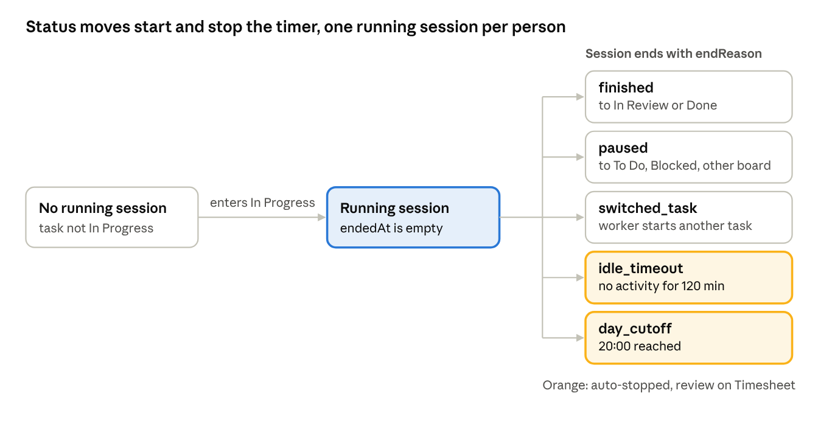
work session states · 1 start, 5 end reasons
The three grey endings come from a person or an agent moving tasks. The two orange endings are automatic and set needsReview.
Trigger | Effect on sessions | endReason
Task enters In Progress (web or agent) | Close every other open session of the worker; open one for this task | Others: switched_task
Task leaves In Progress for In Review or Done | Close the task's open session | finished
Task leaves In Progress for To Do or Blocked | Close the task's open session | paused
Task moves to another board while In Progress | Close the session and open a new one on the new board | paused
No activity for idleTimeoutMinutes (default 120) | Close at the last activity time; needsReview = true | idle_timeout
dayCutoff reached (default 20:00) | Close at the cutoff; needsReview = true | day_cutoff
Manual entry | Add a closed session (source: 'manual') | —

ID | Requirement | Pri | Status
REQ-TSK-020 | A person shall have at most one running session at a time. | M | Built
REQ-TSK-021 | The worker is the task's assignee, or the person moving it if there is none. | M | Built
REQ-TSK-022 | A task with subtasks is a container: it gets no timer, and its subtasks are timed. | M | Built
REQ-TSK-023 | Pointer or keyboard activity shall refresh lastActivityAt on the user's open web session, at most once a minute. | M | Built
REQ-TSK-024 | Auto-stops shall be checked every 60 s, and on the server in production. | M | Demo
REQ-TSK-025 | Manual time shall be more than 0 and at most 24 h, not on a future day, rounded to 15 minutes. Only Admin, PM and engineering lead may log time for others. | M | Built
REQ-TSK-026 | Manual time shall not overlap the same person's other sessions. | S | New
REQ-TSK-027 | Sessions with needsReview shall be listed on the Timesheet for the owner or manager to confirm or correct. | M | Built
REQ-TSK-028 | Changing the assignee of an In Progress task shall close the old worker's session and open one for the new worker. | S | New
REQ-TSK-029 | Worked time = the task's sessions plus its subtasks' sessions, in rounded minutes. | M | Built
- Given Dev A has task X In Progress, when A moves task Y to In Progress, then X's session ends as switched_task and a new session starts on Y.
- Given a running session with no activity for 120 minutes, when the 60 s check runs, then the session ends at the last activity time with idle_timeout and appears on the Timesheet for review.

3.5 Reports
Report | What it computes
Overview | Work done %, finished in the last 7 days vs the 7 before, finished on time %, open and overdue tasks, hours in the last 7 days, tasks finished per day (14 days), team load (overloaded = 3 or more open tasks and at least 1.5× the average), status and priority mix, sprint burndown, and about 20 health rules listed under "Going well" and "Needs attention"
Timeline | Time used % vs work done % (behind if the gap is more than 10 points), checkpoints (achieved, missed, at risk, on track), late drivers with reasons, plan rows per phase, epic and story
Task time | Worked time (from the timer) vs elapsed time (In Progress → In Review), plus auto-stop counts
Schedule | Read-only Gantt with baseline and revised end, extended or shortened label, an actual-work line per task, day, week or month zoom
"Finished" means In Review or Done, timed from the first move into either. A task stuck in review for more than 3 days, or more than 20 % over its estimate, is flagged.

4. AI Agent Hub and SRS document analyser
An SRS uploaded to a project becomes proposed tasks. A person accepts, edits or rejects each one before anything reaches the board. There are two ways to start the analysis:
- Developer: their own AI agent pulls the SRS through MCP tools.
- PM or anyone without a terminal: an "Analyze with AI" button runs the analysis on the server.
Both paths end in the same proposal store and the same review gate.
Where the prototype stands:
- The MCP flow is a simulated walkthrough (How it works).
- Project files store metadata only.
- generateSuggestedTasksFromSrs ignores its inputs. After a 1.45 s fake progress bar it returns the same 6 e-signature tasks.
Everything in §4.3–§4.5 marked New replaces that.

4.1 Interaction model: why the agent pulls
In MCP the agent is always the caller (§1.3). FlashSign cannot push "analyse this" to an agent. The design therefore:
- Puts each SRS in a queue (analysisStatus = 'waiting_for_agent') when someone asks for agent analysis.
- Lets the person trigger their agent with one prompt. The web app shows a Copy prompt button, for example "Analyse the waiting SRS for project FS using the FlashSign tools."
- The agent calls list_pending_srs → get_srs_text → (its own model reads the text) → propose_srs_tasks.
- The web app shows the proposals live and notifies the person who queued it.
The browser path skips the agent. The server sends the extracted text to the LLM API and writes the same proposal objects. The API key lives only on the server.
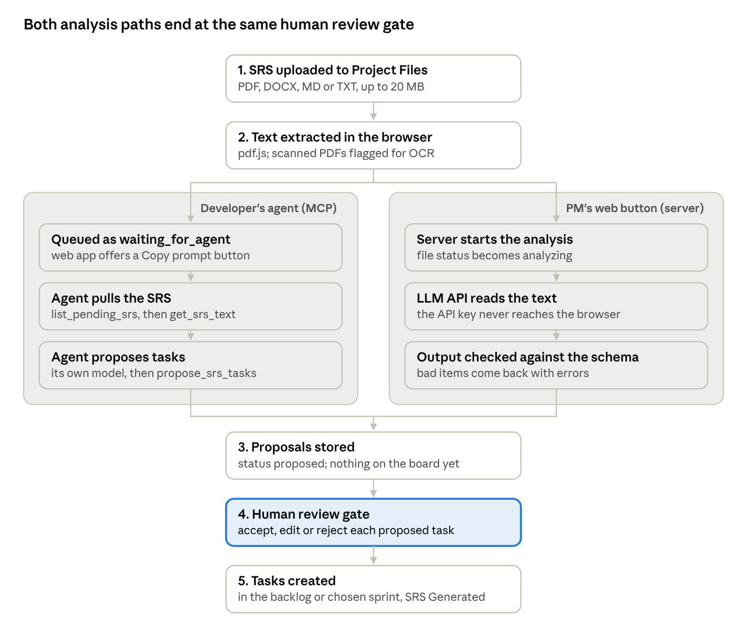
SRS analysis · two paths, one review gate
The two paths differ only in who runs the model. Blocked projects never enter the agent path (§4.6), and no path can create a task without step 4.

4.2 Agent connection and tokens
Item | Rule
Supported agents | Claude Code (Anthropic), Codex (OpenAI), Gemini CLI and Antigravity (Google): AgentClient
Hub tabs | How it works · Connect · My Tokens · Organisation (Admin only)
Connect guide | 5 steps: create a token, save it as the PM_TOKEN environment variable, paste the per-agent MCP config, check the connection, add AGENTS.md to the repository
Token format | pmat_ + 32 base62 characters, shown once at creation
Token expiry | 30, 90 (default, recommended) or 365 days
Token states | active → expired (date passed) or revoked (revokedAt); no delete, rename or extend
Organisation policy | enabled, allowedAgents[], idleTimeoutMinutes (30/60/120/240), dayCutoff (20:00), allowClaimUnassigned, blockedProjectIds[]

ID | Requirement | Pri | Status
REQ-AI-001 | Tokens shall be stored as a SHA-256 hash with the last 4 characters for display. The full value is shown once only. | M | New (prototype keeps the last 4 only)
REQ-AI-002 | Every MCP request shall carry Authorization: Bearer <token>. Expired, revoked or unknown tokens get HTTP 401. | M | New
REQ-AI-003 | Requests shall be refused when the policy is enabled = false, or when the client (from the MCP initialize clientInfo) is not in allowedAgents. | M | New (today the UI only)
REQ-AI-004 | "Check connection" shall call the server and show the token's last use and the agent that used it. | M | New (today a 1.2 s fake)
REQ-AI-005 | A user may revoke their own tokens. An Admin may revoke anyone's. Revoking takes effect on the next call. | M | Built (UI)

4.3 MCP tool catalogue
Every tool acts as the token's owner, never as another user. Tools return JSON. Errors use the MCP error result with a stable code.
Tool | Input | Result and rules | Status
list_my_tasks | projectKey?, status? | Owner's tasks, without blocked projects | Simulated
get_task | taskKey | Task, subtasks, acceptance criteria, comments | Simulated
get_active_work | — | The owner's running session, if any | Simulated
start_task | taskKey | Moves the task to In Progress and starts a session with source = <agent> (closes others as switched_task). Unassigned tasks only if allowClaimUnassigned. | Simulated
add_progress_note | taskKey, text | Adds a task comment marked "(via <Agent>)" and refreshes lastActivityAt | Simulated (not saved as a comment)
pause_task | taskKey | Ends the session as paused and moves the task to To Do | New
finish_task | taskKey, summary | Ends the session as finished and moves the task to In Review. An agent can never set Done. | Simulated
log_time | taskKey, minutes, date, note? | Manual session, with the REQ-TSK-025/026 rules | New
list_pending_srs | projectKey? | SRS files with waiting_for_agent that the owner can access: fileId, name, project, pages, words | New
get_srs_text | fileId, fromPage?, toPage? | Extracted text with [page N] markers, in chunks of at most 50,000 characters, plus nextPage | New
propose_srs_tasks | fileId, tasks[] (see §4.4) | Validates and stores proposals, sets the file to proposed, notifies the requester; returns batchId and per-task errors | New
get_proposal_status | batchId | Counts of accepted, edited and rejected tasks, and the created task keys | New

ID | Requirement | Pri | Status
REQ-AI-010 | The server shall implement MCP over Streamable HTTP at https://<host>/mcp and support initialize, tools/list and tools/call. | M | New
REQ-AI-011 | Every tool call shall write an AgentEvent (userId, agent, action, taskId/fileId, detail, at), shown in My work today and the Hub activity. | M | Built (simulated actions)
REQ-AI-012 | Each token shall be limited to 60 tool calls a minute, and to 10 propose_srs_tasks calls an hour. | S | New

4.4 SRS analyser: end-to-end flow
- Upload. A PM uploads the SRS (PDF, DOCX, MD or TXT, ≤ 20 MB) in Project › Files and chooses the category SRS. The file and its SHA-256 hash are stored.
- Extract. The browser extracts the text page by page: pdf.js getTextContent for PDF, a DOCX reader for Word, the raw text for MD and TXT. The text is uploaded with [page N] markers. A PDF with fewer than 20 characters per page on average is flagged as "Scanned — needs OCR" and cannot be analysed until OCR runs.
- Choose a path. Analyze with AI (server) or Analyze with my agent (queue plus Copy prompt).
- Analyse. The model reads the text and returns tasks. Long documents are split at headings into parts of up to 50,000 characters. Duplicate titles across parts are merged.
- Propose. Proposals are stored with status = 'proposed', linked to the file version (its hash). Nothing is created on the board.
- Review. The requester opens the Review modal and accepts, edits or rejects each proposal (§4.5).
- Commit. Accepted proposals become tasks in the chosen plan level, sprint and assignee (defaults: backlog, no sprint, unassigned), tagged SRS Generated and linked to sourceDocumentId and sourceSection.
- History. The file shows tasks created: N. Each analysis run adds a history entry; it never replaces earlier ones.
Proposed task schema (propose_srs_tasks.tasks[] and server output)
Field | Type and rule
title | string, 5–120 characters
description | string, at most 4,000 characters
acceptanceCriteria | string[], 1–10 items, each written as Given/When/Then or a testable statement
type | story | task | bug
priority | low | medium | high | critical
points | 1, 2, 3, 5, 8 or 13
sourceSection | string, required: the SRS heading or requirement ID it came from
sourcePage | number, optional
suggestedParent | optional name of a phase, epic or story in the project
A batch holds at most 100 tasks. Invalid items are returned with errors, and valid ones are kept.
SRS file states
From | Event | To
— | Uploaded with category SRS | not_analyzed
not_analyzed | Text extracted | ready (or needs_ocr)
ready | Analyze with my agent | waiting_for_agent
ready · waiting_for_agent | Analyze with AI starts | analyzing
waiting_for_agent · analyzing | Proposals stored | proposed
analyzing | Model error or timeout (120 s) | failed (retry allowed)
proposed | Review committed | tasks_created
tasks_created | Analyse again (new version) | ready

ID | Requirement | Pri | Status
REQ-AI-020 | Project Files shall store the SRS content and its extracted text. | M | New
REQ-AI-021 | Analyze with AI shall run on the server and never expose an API key to the browser. Output shall be forced to the schema above. | M | New
REQ-AI-022 | Analysis shall use the real document text. The same input should give stable output (temperature 0). | M | New (today hard-coded)
REQ-AI-023 | Each proposal shall cite sourceSection. A proposal without one is rejected. | M | New
REQ-AI-024 | Analysing the same file version again shall warn and show tasks already created from it, so none are duplicated. | M | New
REQ-AI-025 | The SRS text is data, not instructions. The server prompt and the agent's AGENTS.md shall say so, and the server shall ignore any "instructions" found in the document. | M | New

4.5 Human review gate
ID | Requirement | Pri | Status
REQ-AI-030 | No proposal shall become a task without a person committing it in the Review modal. No tool and no setting may skip this. | M | Built
REQ-AI-031 | The modal shall have tabs All, Ready to accept and Excluded, with a count on each. | M | Built
REQ-AI-032 | Each proposal shall offer Edit (title, priority, type, description, criteria), Reject (optional reason) and Restore. Edited proposals are marked. | M | Built
REQ-AI-033 | The modal shall offer select all, bulk accept and bulk reject. | S | New
REQ-AI-034 | Commit shall let the user choose the target plan level, sprint and assignee before tasks are created. | S | New
REQ-AI-035 | Commit shall create tasks with unique keys and record one history entry per proposal (accepted, edited or rejected). | M | Built (keys can clash; history is replaced)
REQ-AI-036 | Only the person who started the analysis, an Admin or the project's PM may commit. | M | New
- Given 12 proposals with 2 rejected and 1 edited, when the PM clicks "Accept 10 Tasks", then 10 tasks are created in the backlog with label SRS Generated, the history shows 10 accepted (1 edited) and 2 rejected, and the file shows tasks created: 10.
- Given proposals from an agent, when nobody opens the review, then no task exists on the board.

4.6 Security: blockedProjectIds and agent limits
Admins can block projects from agents, for example ones under strict client confidentiality. Today the setting is saved but not enforced anywhere. Enforcement must be in the server's tool layer, not the UI, because agents never see the UI.
resolveProjectFor(toolCall): // from taskKey, fileId or projectKey
project = lookup(...)
if project.id in org.agentSettings.blockedProjectIds:
audit(agentEvent 'blocked', tool, project)
return error { code: 'PROJECT_BLOCKED', message: 'This project is not available to AI agents.' }
list tools (list_my_tasks, list_pending_srs): filter out blocked projects silently
ID | Requirement | Pri | Status
REQ-AI-040 | Every tool that reads or changes data shall find the item's project first and refuse with PROJECT_BLOCKED if the project is blocked. | M | New
REQ-AI-041 | List tools shall leave out items from blocked projects. | M | New
REQ-AI-042 | On a blocked project, "Analyze with my agent" shall be hidden. "Analyze with AI" (server) is allowed only if the Admin turns on `allowServerAiOnBlocked` (default off). | S | New
REQ-AI-043 | Agents shall act only on the token owner's own tasks, plus unassigned tasks if allowClaimUnassigned, and can never set Done or delete. | M | New (UI text only today)
REQ-AI-044 | Blocking a project takes effect on the next tool call. Running agent sessions on it are stopped as paused. | S | New
- Given project FS is blocked, when an agent calls get_srs_text for a file in FS, then it gets PROJECT_BLOCKED, no text is returned, and an event is logged.
- Given project FS is blocked, when an agent calls list_pending_srs, then FS files are not listed.

5. Non-functional requirements and technical constraints
The prototype's limits come from the browser. Production must meet the targets below on a mid-range laptop (4 cores, 8 GB RAM, Chrome or Edge, the latest two versions) and on a 4G connection.

5.1 Client-side storage
Store | Holds | Limit and behaviour
localStorage flashsign-proto-state-v6 | All app state as one JSON string, plus flashsign_demo_* auth keys | About 5 MB per site; writes block the page; a write that fails due to quota loses the change
IndexedDB flashsign-demo-files › files | PDF bytes keyed by fileId | Browser quota (often a share of free disk); can be cleared by the browser under storage pressure unless persistent storage is granted

ID | Requirement | Pri | Status
NFR-001 | Binary files shall never be stored in localStorage or in the state JSON. | M | Built
NFR-002 | The prototype shall catch QuotaExceededError on save and tell the user the change was not saved. | S | New
NFR-003 | The prototype shall request navigator.storage.persist() before storing the first PDF. | C | New
NFR-004 | A request whose PDF bytes are missing shall show "File not available on this device" instead of failing. Samples shall be rebuilt from sampleId. | M | Built
NFR-005 | In production the browser keeps only a cache. The server is the source of truth, so data is the same on every device. | M | New
NFR-006 | Changing the shape of the saved state shall raise the key version (-v6 → -v7) or migrate the old data. | M | Built

5.2 Performance and rendering
ID | Requirement | Target | Status
NFR-010 | pdf.js shall run in its web worker, never on the main thread. | — | Built
NFR-011 | Page canvases shall be rendered only when near the viewport (virtualised), and pages far off screen shall be released. | A 200-page PDF opens with ≤ 3 pages rendered | New
NFR-012 | First page visible after opening a 5 MB, 20-page PDF | ≤ 2 s | —
NFR-013 | Dragging or resizing a field shall keep up with the pointer. | ≥ 50 fps | Built
NFR-014 | Signed PDF build for 3 documents, 30 pages and 40 fields | ≤ 5 s | —
NFR-015 | Board with 300 cards: first render and drag response | ≤ 1 s / ≤ 100 ms | —
NFR-016 | MCP tool response, excluding the model's time | p95 ≤ 500 ms | New
NFR-017 | Server SRS analysis of a 50-page SRS | ≤ 120 s, with visible progress | New

5.3 Security, privacy and compliance
ID | Requirement | Pri | Status
NFR-020 | All traffic over TLS 1.2+. Files and databases encrypted at rest (AES-256). | M | New
NFR-021 | Passwords hashed with Argon2id or bcrypt (cost ≥ 12). The demo rule that Demo123! opens any account shall be removed. | M | New
NFR-022 | A signing link shall carry a random token of at least 128 bits, bound to one signer and one request, that expires with the request and dies after completion, decline or cancel. | M | New
NFR-023 | The audit trail shall be append-only and hash-chained (REQ-AGR-063). The original and final PDFs shall each have a SHA-256 checksum (REQ-AGR-060/061). | M | New
NFR-024 | Each signing event shall record time (UTC, from the server clock), IP address, user agent and consent text version. | M | New
NFR-025 | Agent tokens hashed at rest. Each tool call is checked for project block, ownership and policy (§4.6). | M | New
NFR-026 | Personal data (signer names, emails, IP addresses) is used only for signing and audit. Exports and deletion requests follow GDPR and the Sri Lanka Personal Data Protection Act No. 9 of 2022, except where the retention rule applies (REQ-AGR-066). | M | New
NFR-027 | Uploaded files shall be checked for malware before they are made available to others. | S | New
NFR-028 | SRS text sent to an LLM provider shall go only to a provider with a no-training, no-retention agreement, and only when the org allows it. | M | New

5.4 Usability, accessibility and reliability
ID | Requirement | Pri | Status
NFR-030 | The signing page shall work on phones (375 px wide and up) with touch drawing for signatures. | M | Built
NFR-031 | All screens shall meet WCAG 2.2 AA. Every field type can be reached and filled by keyboard. | S | New
NFR-032 | Date and time are stored in UTC and shown in the user's time zone. Expiry uses the sender's time zone. | M | New
NFR-033 | Service availability 99.5 % a month. Daily backups kept 30 days; restore tested every quarter. | M | New
NFR-034 | Next.js 16 rule: any page using useSearchParams shall be wrapped in Suspense. Read node_modules/next/dist/docs before using an API, because it differs from older versions. | M | Built

6. Appendices

6.1 Production backend contract (summary)
These endpoints replace the client-side functions named in §2–§4. All take and return JSON; errors return { code, message }.
Endpoint | Replaces | Notes
POST /api/files (multipart) | readPdfUpload, savePdfFile | Returns PdfAttachment with sha256
GET /api/files/:id | loadPdfFile | Signed, short-lived URL
POST /api/signature-requests | saveSignatureDraft | status: 'draft'
PATCH /api/signature-requests/:id | Draft auto-save | Only while draft
POST /api/signature-requests/:id/send | createPdfRequest | Runs the §2.5 checks again on the server
POST /api/signature-requests/:id/cancel · /remind · /trash · /restore | Matching functions | Sender only
GET /api/sign/:token | Signing page load | Marks the signer viewed
POST /api/sign/:token/complete | completePdfSigning | Body: values, signature, consent: true
POST /api/sign/:token/decline | declineSignatureRequest | Body: reason
GET /api/signature-requests/:id/signed.pdf | downloadSignedPdf | Final PDF built on the server
POST /api/tasks/:id/move | moveTask + trackStatusMove | Server applies the timer rules
POST /api/projects/:id/files/:fileId/analyze | generateSuggestedTasksFromSrs | mode: 'server' | 'agent'
POST /api/srs-proposals/:batchId/commit | Review commit | Body: accepted ids, edits, target level, sprint and assignee
POST /mcp | Simulated tools | MCP Streamable HTTP (§4.3)

6.2 Open questions
- ☐ Which law governs signatures for the first customers: Sri Lanka ETA 2006, EU eIDAS, US ESIGN, or several? This decides whether SES is enough.
- ☐ Which certificate authority and timestamp service will sign final PDFs (REQ-AGR-062)?
- ☐ Retention period for signed documents and audit trails: is 7 years right?
- ☐ Which LLM provider and model does the server SRS analysis use, and who pays for it?
- ☐ Must signers verify their identity beyond email (SMS code, ID check) for some document types?
- ☐ Should text documents from the Documents editor move to the PDF engine, by converting them to PDF before sending?

6.3 Known gaps in the prototype
Area | Gap | Requirement
Agreements | Reminders and expiry run only while a tab is open | REQ-AGR-053
Agreements | A signed request stays in the signer's "waiting" list | REQ-AGR-073
Agreements | No hashes or certificate; summary page says "demo" | REQ-AGR-060–064
Projects | Project key uniqueness not checked; task keys can clash | REQ-PRJ-002, REQ-TSK-007
Projects | Most task actions have no role check | REQ-PLT-001, REQ-TSK-009
Timer | Changing the assignee leaves the timer with the old person | REQ-TSK-028
AI | blockedProjectIds, allowClaimUnassigned, allowedAgents saved but not enforced | REQ-AI-003, 040–043
AI | SRS analysis returns 6 fixed tasks; files have no content | REQ-AI-020–022
AI | SRS history search never filters; history is replaced on re-analysis | REQ-AI-035
Platform | Activity and audit logs are lost on reload | REQ-PLT-005

6.4 Glossary
Term | Meaning
Envelope / request | One signature request: its documents, recipients, fields and history
Signer | A recipient who must sign. Copy and view recipients only receive the document
Field | A box on a page that one signer must fill, stored as page percentages
Flattening | Writing the field values onto the page so they become fixed content
SES / AdES / QES | eIDAS levels: simple, advanced and qualified electronic signature
PAdES | The PDF format for digital signatures, readable in any PDF reader
SHA-256 | A function that gives a file a 64-character fingerprint
MCP | Model Context Protocol: how an AI agent (client) calls tools on a server
Work session | One period of timed work on one task by one person
Plan levels | Phases, epics, stories and subtasks a project chooses to use
Proposal | A task suggested from an SRS, waiting for human review

